**classmethods and staticmethods**

There is difference between classmethods and staticmethods.

Consider the case wherein you want to create a class method. It has to be declared with a ‘decorator’ as shown:

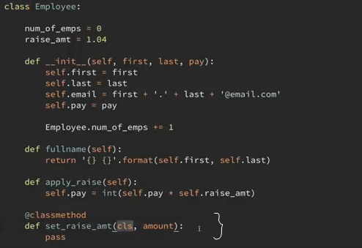

Notice that for instance methods the variable self is mentioned, but for class methods the variable cls is mentioned explicitly mentioning class methods.

So when the following snippet is run:

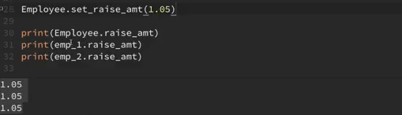

The class method set_raise_amt() is fed the argument 1.05 which changes the class variable raise_amt.

Now consider a case where you have to parse the input strings into separate instance variables:

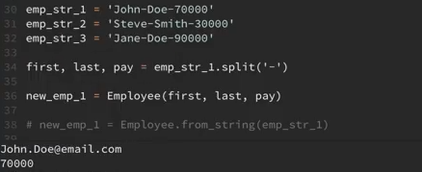

But consider that you want it to be done for every new instance that is created in this class. For this we can create a new method as an alternative constructor:

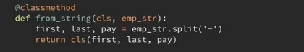

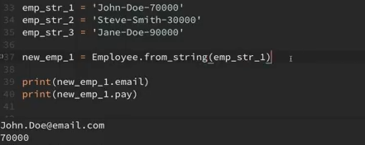

Now moving over to staticmethods. They do not have a variable self or cls unlike methods for instances and class. They are similar to regular functions except that they have a logical connection with classes.

Example:

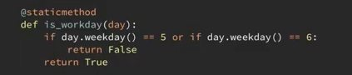

In this case the method does not access the instance variables or the class so there is not need to use self or cls.

